**3.5 Focusing of ﬁelds**

The limit of classical light conﬁnement is achieved with highly focused laser beams. Such beams are used in ﬂuorescence spectroscopy to investigate molec- ular interactions in solutions and the kinetics of single molecules on interfaces [6]. Highly focused laser beams also play a key role in confocal microscopy and op- tical data storage, where resolutions on the order of *λ/*4 are achieved. In optical tweezers, focused laser beams are used to trap particles and to move and position them with high precision [8]. All these ﬁelds require a theoretical understanding of strongly focused light.

The ﬁelds of a focused laser beam are determined by the boundary conditions of the focusing optical element and the incident optical ﬁeld. In this section we will study the focusing of a paraxial optical ﬁeld by an aplanatic optical lens as shown in Fig. 3.5. In our theoretical treatment we will follow the theory established by Richards and Wolf [9, 10]. The ﬁelds near the optical lens can be formulated by the rules of Geometrical Optics. In this approximation the ﬁniteness of the optical wavelength is neglected (*k* → ∞) and the energy is transported along light rays. The average energy density is propagated with the velocity *v* = *c/n* in the direction perpendicular to the geometrical wavefronts. To describe an aplanatic lens we need two rules: (1) the sine condition and (2) the intensity law. These rules are illustrated in Fig. 3.6. The *sine condition* states that each optical ray which emerges from or converges to the focus F of an aplanatic optical system intersects its conjugate ray on a sphere of radius *f* (Gaussian reference sphere), where *f* is the focal length of the lens. By conjugate ray, one understands the refracted or incident ray that propagates parallel to the optical axis. The distance *h* between the optical axis and the conjugate ray is given by

*θ* being the divergence angle of the conjugate ray. Thus, the sine condition is a prescription for the refraction of optical rays at the aplanatic optical element. The *intensity law* is nothing but a statement of energy conservation: the energy ﬂux along each ray must remain constant. As a consequence, the electric ﬁeld strength of a spherical wave has to scale as 1*/r*, *r* being the distance from the origin.

The intensity law ensures that the energy incident on the aplanatic lens equals the energy that leaves the lens. We know that the power transported by a ray is *P* = *(*1*/*2*)Zµ*−*ε*1*/*2|**E**|2d*A*, where *Zµε* is the wave impedance and d*A* is an inﬁnitesimal cross-section perpendicular to the ray propagation. Thus, as indicated in the ﬁgure, the ﬁelds before and after refraction must fulﬁll

Since in practically all media the magnetic permeability at optical frequencies is equal to one (*µ*=1), we will drop the term √*µ*2*/µ*1 for the sake of more convenient notation.

Polarization singularities are lines in space, and points in a plane, P, pierced by the line, where a defining property of the polarization ellipse becomes undefined (singular) —such lines are generic to three-dimensional (3D) opti- cal vector fields [1–20]. On lines (at points) of circular polarization, C lines (C points), the major axis α and the minor axes β of the polarization ellipse become equal, both become singular, and the ellipse degenerates into a circle, the C circle. α and β of the polarization ellipses surrounding a C line, however, remain well defined, and their projections onto P rotate about the central C point, generically with odd-half-integer winding number (neICt rotation angle divided by 2π) IC ¼ �1=2 [1–6].

Using the sine condition, our optical system can be represented as shown in Fig. 3.7. The incident light rays are refracted by the reference sphere of radius *f* . We denote an arbitrary point on the surface of the reference sphere as *(x*∞*, y*∞*,z*∞*)* and an arbitrary ﬁeld point near the focus by *(x, y, z)*. The two points are also represented by the spherical coordinates *( f, θ, φ)* and *(r, ϑ, ϕ)*, respectively.

为了描述入射光线在参考球上的折射，我们引入单位向量nρ、nφ和nθ，如图3.7所示。nρ和nφ是柱坐标系的单位矢量，而nθ和nφ一起表示球坐标系的单位矢量。我们认识到参考球将柱坐标系（入射光束）转换为球面坐标系（聚焦光束）。参考球面上的折射最容易通过将入射矢量Einc分解为表示为和的两个分量来计算。指数（s）和（p）分别代表s极化和p极化。根据单位向量，我们可以将两个字段表示为

To describe refraction of the incident rays at the reference sphere we introduce the unit vectors **n***ρ*, **n***φ*, and **n***θ*, as shown in Fig. 3.7. **n***ρ* and **n***φ* are the unit vec- tors of a cylindrical coordinate system, whereas **n***θ* together with **n***φ* represent unit vectors of a spherical coordinate system. We recognize that the reference sphere transforms a cylindrical coordinate system (incoming beam) into a spherical co- ordinate system (focused beam). Refraction at the reference sphere is most conve- niently calculated by splitting the incident vector **E**inc into two components denoted as %FontSize=16
%TeXFontSize=16
\documentclass{article}
\pagestyle{empty}
\begin{document}
\[
\mathbf{E}_{\text {inc }}^{(\mathrm{s})}
\]
\end{document} and %FontSize=16
%TeXFontSize=16
\documentclass{article}
\pagestyle{empty}
\begin{document}
\[
\mathbf{E}_{\mathrm{inc}}^{(\mathrm{p})}
\]
\end{document}. The indices *(*s*)* and *(*p*)* stand for s-polarization and p-polarization, respectively. In terms of the unit vectors we can express the two ﬁelds as

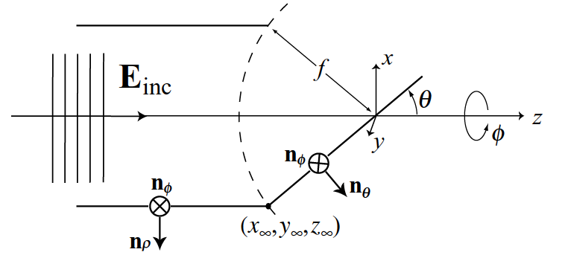

Figure 3.7 Geometrical representation of the aplanatic system and deﬁnition of coordinates.

As shown in Fig. 3.7 these two ﬁelds refract at the spherical surface differently. While the unit vector **n***φ* remains unaffected, the unit vector **n***ρ* is mapped into **n***θ*. Thus, the total refracted electric ﬁeld, denoted by **E**∞, can be expressed as

For each ray we have included the corresponding transmission coefﬁcients *t*s and *t*p as deﬁned in Eqs. (2.50). The factor outside the brackets is a consequence of the intensity law to ensure energy conservation. The subscript ∞ was added to indicate that the ﬁeld is evaluated at a large distance from the focus *(x, y, z)* = *(*0*,* 0*,* 0*)*.

The unit vectors **n***ρ*, **n***φ*, **n***θ* can be expressed in terms of the Cartesian unit vec- tors **n***x*, **n***y*, **n***z* using the spherical coordinates *θ* and *φ* deﬁned in Fig. 3.7.

Inserting these vectors into Eq. (3.39) we obtain

which is the ﬁeld in Cartesian vector components just to the right of the refer- ence sphere of the focusing lens. We can also express **E**∞ in terms of the spatial frequencies *kx* and *ky* by using the substitutions

The resulting far-ﬁeld on the reference sphere is then of the form **E**∞*(kx, ky)* and can be inserted into Eq. (3.33) to rigorously calculate the focal ﬁelds. Thus, the ﬁeld **E** near the focus of our lens is entirely determined by the far-ﬁeld **E**∞ on the reference sphere. All rays propagate from the reference sphere towards the focus *(x, y, z)*=*(*0*,* 0*,* 0*)* and there are no evanescent waves involved.

Due to the symmetry of our problem it is convenient to express the angular spectrum representation Eq. (3.33) in terms of the angles *θ* and *φ* instead of *kx* and *ky*. This is easily accomplished by using the substitutions in Eq. (3.44) and expressing the transverse coordinates *(x, y)* of the ﬁeld point as

which is illustrated in Fig. 3.8. We can now express the angular spectrum represen- tation of the focal ﬁeld (Eq. 3.33) as

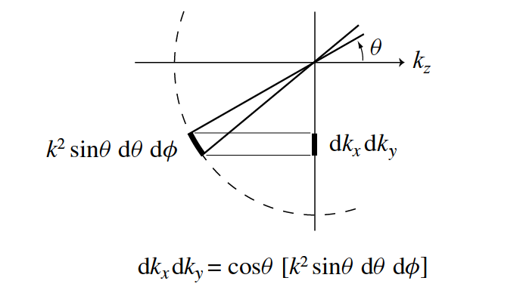

Fig 3.8 Illustration of the substitution *(*1*/kz)* d*kx* d*ky* = *k* sin *θ* d*θ* d*φ*. The sphere stay*z* e=qu1a*/*l.*(k* c

In order to replace the planar integration over *kx, ky* by a spherical integration over *θ, φ* we must transform the differentials as

We have replaced the distance *r*∞ between the focal point and the surface of the ref- erence sphere by the focal length *f* of the lens. We have also limited the integration over *θ* to the ﬁnite range [0…… *θ*max] because any lens will have a ﬁnite size. Fur- thermore, since all ﬁelds propagate in the positive *z*-direction we retained only the + sign in the exponent of Eq. (3.33). Equation (3.47) is the central result of this sec- tion. Together with Eq. (3.43), it allows us to calculate the focusing of an arbitrary optical ﬁeld **E**inc by an aplanatic lens with focal length *f* and numerical aperture

where *n* = *n*2 is the index of refraction of the surrounding medium. The ﬁeld distribution in the focal region is entirely determined by the far-ﬁeld **E**∞. As we shall see in the next section, the properties of the laser focus can be engineered by adjusting the amplitude and phase proﬁle of **E**∞.